Rajshahi University of Engineering & Technology
Department of Computer Science of Engineering

Experiment No: 05
Name of Experiment: Linked Lists

Submitted by:

Name: Md. Ariful Islam
Roll No.: 1803046
Group: 2nd Thirty
Date of Exp.: 30-09-2019
Date of sub. : 14-09-2019
Series: 18 Series

Submitted to:

Rizoan Toufiq
Assistant Professor
Department of Computer Science & Engineering
Rajshahi University of Engineering & Technology

Machine configuration:
ASUS X510UF
CORE I5 8th Gen Processor
Up To 3.4 GHz
8 GB RAM
OS WIN 10

INDEX

Preblem No. | Name of Problem | Page No.
01. | Deleting a given node from a linked list | 04-05
02. | Deleting a node with a given ITEM of information | 06-09
03. | Traversing a Circular Header List | 10-11
04. | Finding the location of the first node in circular header list when contains ITEM | 12-13
05. | Deleting the node in circular header list with a given ITEM of information | 14-17
06. | <empty>
07. | <empty>
08 | <empty>
09 | <empty>
10. | <empty>

Theory: A header linked list is a linked list which always contains a special node, called the at the beginning of the list. The following are two kinds of widely used header lists:

- A grounded header list is a header list where the last node contains the null pointer.

- A circular header list is a header list where the last node points back to the header node.

A two-way list is a linear collection of data elements,called nodes,where each nodes N is divided into three parts:

- An information field INFO which contains the data of N.

- A pointer field FORW which contains the location of the next node in the list.

- A pointer field BACK which contains the location of the preceding node in the list.

Operations on Two-Way Lists:
- Traversing
- Searching
- Deleting
- Inserting etc.

Problem 1: Deleting a given node from a linked list.

Flow Chart:

START

LOCP : NULL
START : LINK[START]
yes no

LINK[LOCP] : LINK[LOC]

LINK[LOC] : AVAIL
AVAIL: LOC

END

Algorithm: DEL (INFO, LINK, START, AVAIL, LOC, LOCP)
This algorithm delete the node N with location LOC. LOCP is the location of the node which precedes N or, when N is the first node, LOCP = NULL.
- IF LOCP=NULL then:
Set START:=LINK[START]. [Delete First Node]
Else:
Set LINK[LOCP]:=LINK[LOC] [Delete N node]
[End of IF structure]
2. LINK [LOC] = AVAIL and AVAIL := LOC
3. Exit.

Code:

#include<stdio.h>

int main(){

char info[12]={'\0','\0','U','E','C','R','T','E','\0','\0','S','\0'};

int link[12]={10,'\0',8,'\0',11,3,5,7,1,12,4,2};

int loc=4,locp=11,start=6,avail=1,ptr;

ptr=start;

while(ptr!='\0'){

printf("%d %c %d\n",ptr,info[ptr-1],link[ptr-1]);

ptr=link[ptr-1];

}

if(locp=='\0')

start=link[start-1];

else

link[locp-1]=link[loc-1];

link[loc-1]=avail;

avail=loc;

ptr=start;

while(ptr!='\0'){

printf("\n%d %c %d",ptr,info[ptr-1],link[ptr-1]);

ptr=link[ptr-1];

}

return 0;

}

Output:
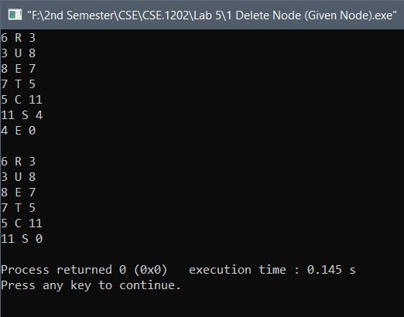

Problem 2: Deleting a node with a given ITEM of information.

Flow Chart:

START
P
Q

i++
i : 1
i : n
>

yes no
LOC
<
! =
ITEM : INFO[i]
LOCP : NULL
no
= =
LOC : i
yes
START :
LINK[START]
LINK[LOCP] :
LINK[LOC]
j : 1
j : n
>
j++

Q
<
!=
LOC : LINK[j]

LINK[LOC] : AVAIL
AVAIL: LOC
= =
LOCP : j

BRAEK

P
END

Algorithm: :
DEL (INFO, LINK, START, ITEM,AVAIL, LOC, LOCP)
This algorithm delete the node N which contain information ITEM. At first it finds the location LOC of ITEM. It also finds the location LOCP of the node which precedes N or, when N is the first node, LOCP = NULL.
- Repeat for i = 1 to n by 1
- If ITEM=INFO[i] then:
Set LOC=i.
[End of IF structure]
- Repeat for j=1 to n by 1
- If LOC=LINK[j] then:
Set LOCP=j and Break.
[End of IF structure]
[End of Step 3 loop]
Break.
[End of Step 1 loop]
- If LOC !=True then: Exit.
Else :
- If LOCP=NULL then:
Set START:=LINK[START]. [Delete 1st Node containing ITEM]
Else:
Set LINK[LOCP]:=LINK[LOC] [Delete N node containing ITEM]
[End of IF structure]
- LINK [LOC] = AVAIL and AVAIL := LOC
[End of Step 5 IF structure]
- Exit.

Code:

#include<stdio.h>

int main(){
char info[12]={'\0','\0','U','E','C','R','T','E','\0','\0','S','\0'},item='T';
int link[12]={10,'\0',8,'\0',11,3,5,7,1,12,4,2};
int i,j,loc,locp,start=6,avail=1,ptr;
ptr=start;
while(ptr!='\0'){
printf("%d %c %d\n",ptr,info[ptr-1],link[ptr-1]);
ptr=link[ptr-1];
}
for(i=0;i<12;i++){
if(item==info[i]){
loc=i+1;
for(j=0;j<12;j++){
if(loc==link[j]){
locp=j+1;
break;
}
}
break;
}
}

if(locp=='\0')
start=link[start-1];
else
link[locp-1]=link[loc-1];

link[loc-1]=avail;
avail=loc;
ptr=start;
while(ptr!='\0'){
printf("\n%d %c %d",ptr,info[ptr-1],link[ptr-1]);
ptr=link[ptr-1];
}

return 0;
}

Output :

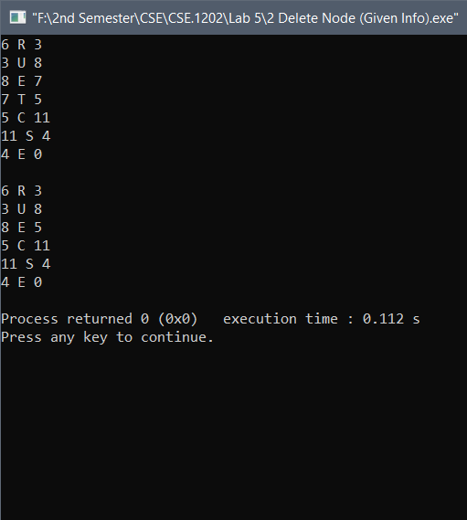

Problem 3: Traversing a Circular Header List.

Flow Chart:

START

PTR : LINK[START]

PTR : LINK[PTR]
PTR != START
yes no

END
INFO[PTR]

Algorithm: Let LIST be a circular header list in memory. This algorithm traverses LIST, applying an operation PROCESS to each node of LIST.

1. Set PTR:=LINK[START].

2. Repeat Steps 3 and 4 while PTR ≠ START

3. Apply PROCESS to INFO[PTR].

4. Set PTR:=LINK[PTR].

[End of step 2 loop]

5. Exit.

Code:

#include<stdio.h>

int main()
{
char info[12]={'\0','\0','U','E','C','R','T','E','\0','\0','S','\0'};
int link[12]={10,'\0',8,6,11,3,5,7,1,12,4,2};
int start=6,avail=1,ptr;

printf("Current\tInfo\tNext\n");
ptr=link[start-1];
while(ptr!=start)
{
printf("%d \t %c \t %d\n",ptr,info[ptr-1],link[ptr-1]);
ptr=link[ptr-1];
}

return 0;
}

Output :

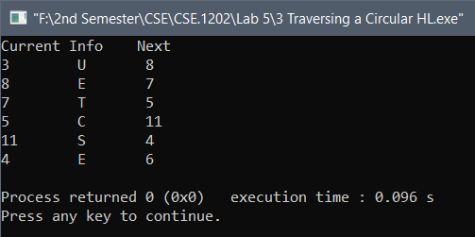

Problem 4: Finding the location of the first node in circular header list when contains ITEM.

Flow Chart :
START

PTR : LINK[START]

ITEM!=INFO[PTR]
&& PTR!=START

yes no

ITEM : INFO[PTR]
!=
PTR : LINK[PTR]
LOC : NULL

= =
LOC : PTR

END

Algorithm: SEARCH (INFO, LINK, START, ITEM, LOC)
LIST is a linked list in memory. This algorithm finds the location LOC of the node where ITEM first appears in LIST, or sets LOC-NULL.
1. Set PTR:= LINK[START]
2. Repeat while INFO[PTR]≠ITEM & PTR≠START
Set PTR =LINK[PTR]
[End of Repeat 2 loop]
3. If ITEM = INFO[PTR] then:
Set LOC:=PTR
Else:
SET PTR := NULL [Search is unsuccessful].
[End of If statement]
4. Exit.
Code:
#include<stdio.h>

int main(){
char info[12]={'\0','\0','U','E','C','R','T','E','\0','\0','S','\0'},item='E';
int link[12]={10,'\0',8,6,11,3,5,7,1,12,4,2};
int start=6,avail=1,ptr,loc;
ptr=link[start-1];
while(ptr!=start){
printf("%d \t %c \t %d\n",ptr,info[ptr-1],link[ptr-1]);
ptr=link[ptr-1];
}
ptr=link[start-1];
while(info[ptr-1]!=item&&ptr!=start){
ptr=link[ptr-1];
}
if(info[ptr-1]==item)
loc=ptr;
else
loc='\0';
printf("\nLocation: %d\n",loc);

return 0;
}

Output:
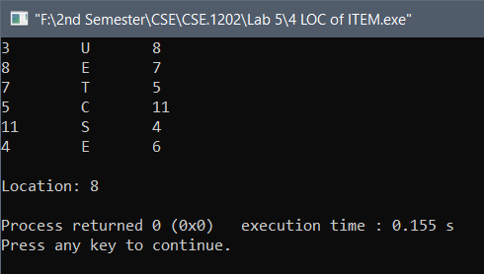

Problem 5: Deleting the node in circular header list with a given ITEM of information.
Flow Chart:
START

PTR: LINK[START]

INFO[PTR]!=ITEM
&&
PTR != START
LOC : PTR
i ++
i : n

no

INFO[PTR] : ITEM
!=
P
yes
= =
PTR : LINK[PTR]

i : 1

>

<
!=
LOC : LINK[i]

= =
LOCP : i

LOCP:LINK[START]
= =
START: LINK[START]

!=
LINK[LOC] : AVAIL
AVAIL : LOC
LINK[LOCP] : LINK[START]

END
P
Algorithm:
DEL (INFO, LINK, START, ITEM,AVAIL, LOC, LOCP)
This algorithm delete the node N which contain information ITEM. At first it finds the location LOC of ITEM. It also finds the location LOCP of the node which precedes N or, when N is the first node, LOCP = LINK[START].
1. Set PTR:= LINK[START]
2. Repeat while INFO[PTR]≠ITEM & PTR≠START
Set PTR =LINK[PTR]
[End of Repeat 2 loop]
- If ITEM ≠ INFO[PTR] then:
Exit.
Else:
Set LOC:=PTR
[End of IF structure]
- Repeat for i=1 to n by 1
- If LOC=LINK[i] then:
Set LOCP=i and Break.
[End of IF structure]
[End of Step 4 loop]
- If LOCP=LINK[START] then:
Set START:=LINK[START]. [Delete 1st Node containing ITEM]
Else:
Set LINK[LOCP]:=LINK[LOC] [Delete N node containing ITEM]
[End of IF structure]
- LINK [LOC] = AVAIL and AVAIL := LOC.
- Exit.

Code:

#include<stdio.h>

int main(){

char info[12]={'\0','\0','U','E','C','R','T','E','\0','\0','S','\0'},item='U';

int link[12]={10,'\0',8,6,11,3,5,7,1,12,4,2};

int i,j,loc,start=6,locp=link[start-1],avail=1,ptr;

ptr=link[start-1];

while(info[ptr-1]!=item&&ptr!=start){

ptr=link[ptr-1];}

if(info[ptr-1]==item){

loc=ptr;

for(i=0;i<12;i++){

if(loc==link[i]){

locp=i+1;

break;

}}}

if(locp==link[start-1])

start=link[start-1];

else

link[locp-1]=link[loc-1];

link[loc-1]=avail;

avail=loc;

return 0;

}

Output:

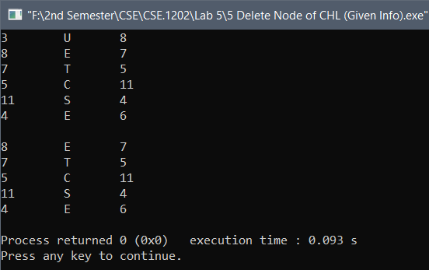

Discussion: The problems were based on Linked List. After trying sometime I had solved the first five problems. But still I have some confussion in the problems of two way linked list and for that I could not complete these problems.

The End

